Indiana State University Economic Impact Analysis



Table of Contents
Foreword
Executive Summary…………………………………………………………………………………………………………3
Introduction………………………………………………………………………………………………………………………..7
Economic Impact of Indiana State University……………………………………………………11
Methodology ………………………………………………………………………………………………………………..….12
Modeling…………………………………………………………………………………………………………………………….15
Total Output Impact……………………………………………………………………………………………………..16
Economic Impact: Day-to-Day Operations…………………………………………………………16
Economic Impact: Maintenance, Repairs, Renovations, and Upgrades..21
Economic Impact: Planned Capital Improvements……………………………………….25
Economic Impact: Sporting and Special Events……………………………………………..29

Executive Summary
Total Impact
The economic impact of ISU on each region of analysis is included in the figure below. In summary, ISU has the following impacts on the State of Indiana:
- $333.5 Million in total economic output (GRP)
- 5,664 jobs are supported by ISU, directly by the University, its employees, and students or due to industry purchases in ISU’s supply chain.
- $233.8 Million in total earnings are associated with those jobs.
Figure I: Economic Impact of ISU; High-Level Summary
FTE JOBS: 5,664
GROSS DOMESTIC PRODUCT: $333.5 Million

Table I: Economic Impact of ISU; High-Level Summary; Region of Analysis

Impact by Region of Analysis
Terra Haute MSA (Vigo, Vermillion, Clay, Sullivan County)
- $294.4 million in total economic output (GRP)
- ISU supports 5,383 jobs in Terre Haute MSA
- $210.4 million in total earnings are associated with those jobs.
Parke County
- $2.1 million in total economic output (GRP)
- ISU supports 30 jobs in Parke County
- $851,400 in total earnings are associated with those jobs.
State of Indiana
- $36.96 million in total economic output (GRP)
- ISU supports 251 jobs in the State of Indiana
- $22.54 million in total earnings are associated with those jobs.
Impact by Spending Category
The total impact numbers reported are attributable to four categories of spending: university day-to-day operations (student spending, staff spending), repairs, renovations, upgrades, planned capital investment projects, and visitor attendance and spending.
Day-to-Day Operations (University spending)
- $248.3 Million in total economic output (GRP)
- ISU day-to-day operations support 4,634 jobs
- $175.99 Million in total earnings are associated with those jobs
Maintenance, Repairs, Renovations, and Upgrades
- $7.2 Million in total economic output (GRP)
- ISU Maintenance, Repairs, Renovations, and Upgrades support 31 jobs.
- $1.8 Million in total earnings are associated with those jobs
Planned Capital Investments
- $74.1 Million in total economic output (GRP)
- ISU Capital Improvements support 933 jobs over the allotted years.
- $54.8 Million in total earnings are associated with those jobs
Sporting and Special Events
- $3.9 Million in total economic output (GRP)
- ISU Sporting and Special Events support 66 jobs
- $1.13 Million in total earnings are associated with those jobs.

Figure II: Economic Impact of ISU, Jobs Supported by Source

Figure III: Economic Impact of ISU GDP Generated by Activity

Fiscal Impact Analysis
In addition to economic impact, ISU impacts state and local tax revenue. As a public institution, ISU is exempt from property and sales taxation; however, its employees pay income tax, and the taxes collected from the sales and earnings generated by through its supply chain and their subsequent rounds of spending throughout the economy can be attributed to ISU.

ISU Day-to-day Operations
- $697,875 in Sub County General Tax
- $1,347,382 in Sub County Special Districts
- $1,792,270 in County Tax
- $10,382,619 in State Tax
- $34,956,652 in Federal Tax
- $49,176,797 in Total Taxes
ISU Sporting and Special Events Taxes
- $38,674 in Sub County General Tax
- $75,154 in Sub County Special Districts
- $62,555 in County Tax
- $372,310 in State Tax
- $231,487 in Federal Tax
- $780,181 in Total Taxe
Introduction
About the Economic Impact Analysis
In 2017, Indiana State University (ISU) partnered with Thomas P. Miller and Associates (TPMA) to develop the Indiana State Economic Impact Analysis, an economic impact analysis outlining ISU's impact on the State of Indiana and regional geographies. Economic activity has changed drastically since the COVID-19 pandemic. The State of Indiana's labor force participation has recovered from the downward spike in 2019. This 2024 economic impact study followed the 2017 study.
The role of universities in the economy significantly impacts the surrounding areas in various ways. Firstly, Universities spend money on day-to-day operations and staff salaries. In addition, ISU invests in capital improvement projects, maintenance, and repair to assist the university's sustainability and operations. University employees purchase goods and services locally and regionally. In addition, capital improvement projects require engineering, construction, and maintenance, which assist in the employment of jobs and subsequent purchasing of goods and services by those workers. During the school year, at its peak, students make an economic impact by offering goods and services. The last component of this analysis focuses on the role of events and visitor spending. Visitors arrive on campus for various reasons, including graduation, athletic events, performance-based events, etc. These visitors also purchase goods and services in the surrounding areas, contributing to the State's economic activity.
About Indiana State University
Indiana State University (ISU) was established in 1865 as “Indiana State Normal School.” Years later, in 1929, the school became known as “Indiana State Teacher’s College.” Modernly called Indiana State University, or “ISU”, the university is in the Wabash River Valley, in Terre Haute, Indiana.
Indiana State University has provided quality and affordable education since 1865. It is committed to core values, including learning, discovery, engagement, and inclusiveness.
- Indiana State University Vision Statement
  - We will be the university of choice for students seeking a distinctive, high-quality education highlighted by challenging experiences that prepare our graduates to contribute to economic vitality and civic and cultural development of their communities and the global society.
- Indiana State University Mission Statement
  - We transform students' lives through a high-quality education infused with experiential learning, community engagement, and career readiness. Our students succeed within a culture of inclusion and support that provides the skills and knowledge to impact Indiana and beyond.
The total enrollment for the Spring 2024 term is 7,660 students. The undergraduate enrollment is 6,046, while the graduate enrollment is 1,614.
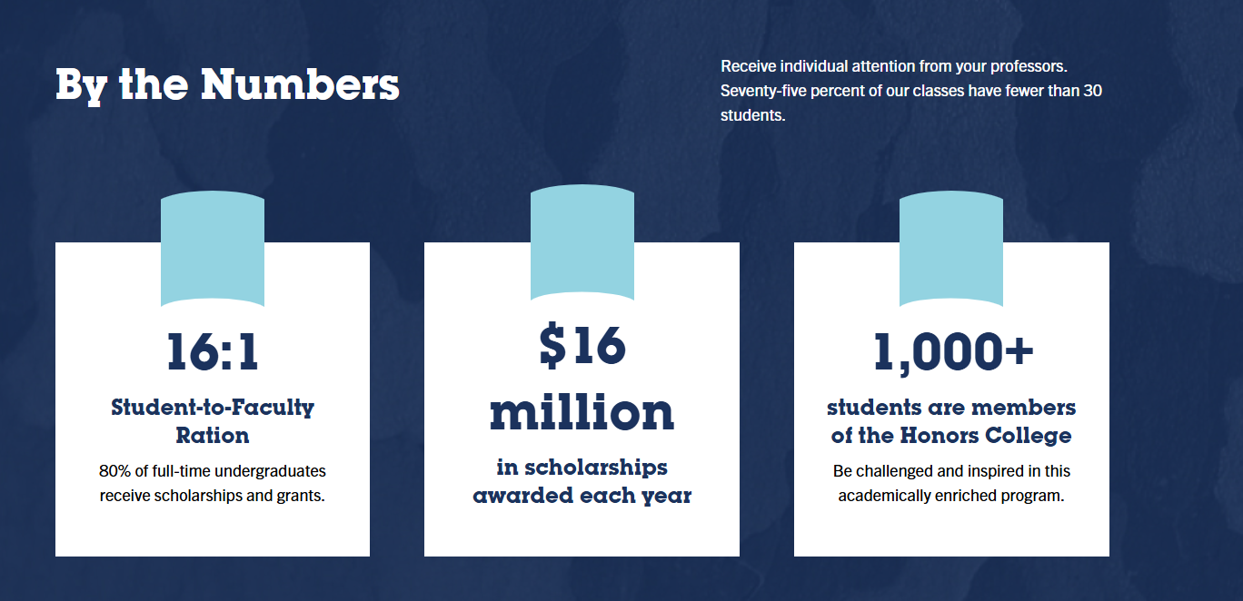
Figure IV: Economic Impact of ISU; High-Level Summary

In addition to the large variety of undergraduate and graduate programs, ISU provides employment-related services for interested students. While enrolled, students may acquire assistance in acquiring on-campus employment from the Career Center. In addition, the Career Center provides resources to assist students in finding internships and careers after graduation. This includes guides on resumes, cover letters, interviews, career succession, and more.
About the Terre Haute Region
ISU is in the City of Terre Haute, the County seat of Vigo County. Clay, Sullivan, Vermillion, and Vigo County represent the Terre Haute MSA Region. In 2023, this region’s population is approximately 184,835. Compared to the region, Vigo County’s population is approximately 105,753, 57.21% of the region.
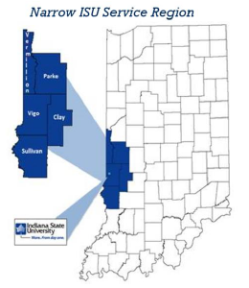
Figure V: ISU Service Region Utilizing Lightcast™ and the categorization of NAICS 2-digit codes (see Appendix), the region is estimated to have approximately 71,229 jobs in 2023. This represents an overall decrease in total jobs by 4% (74,006 in 2017). In addition, in 2023, those 71,229 jobs generated approximately $7,998,530,587 in Gross Regional Product and $508,929,009 in taxes on production and imports, excluding subsidies.
The top three industries that employ the highest number of jobs include Government (13,808), Manufacturing (11,146), and Health Care and Social Assistance (10,180). In the period from 2017 to 2023, the industries that witnessed the highest growth were Management of Companies and Enterprises (20%), Wholesale Trade (19%), and Mining, Quarrying, and Oil and Gas Extraction (16%). On the other hand, the three industries that witnessed the most significant decline include Administrative and Support and Waste Management and Remediation Services (-36%), Utilities (-16%), and Finance and Insurance (-12%).
Of the top three industries with the highest number of jobs, Government and Manufacturing have declined since 2017 (-4 % and -7 %, respectively). On the other hand, the number of jobs in health care and social assistance has increased by 1% since 2017.
Indiana, the Terre Haute MSA region, and Parke County are the three levels of analysis. ISU remains one of the Wabash Valley's main employers, allowing for a large-scale economic impact.
In the following pages, we utilize a rigorous, data-supported approach to estimate economic impact. We apply deductive, largely linear logic to estimate these benefits – in extra earnings, taxes, and GRP generated. To accomplish this, we answer this collection of questions methodologically and in order, specific to
- What are the total dollars generated from Indiana State University?
- What is the total number of jobs Indiana State University generating?
- What is the economic impact of the spending category (capital projects, university operations, alumni spending, student spending, and visitor spending?
- What is the direct, indirect, and induced impact of Indiana State University on Parke County, Terre Haute MSA, and the State of Indiana?

Economic Impact of Indiana State University 2024
The impact of a university on the local and state economy is not limited to direct outputs or spending. At any given time, funds invested by ISU are reinvested within the economy. Employees receiving salaries, wages, benefits, etc., from the university will contribute to the local economy by purchasing goods and services. Contractors, businesses, and other entities hired by the University also contribute to their employees, who contribute to the local economy. Spending is also further delineated by both students and visitors who purchase goods and services locally, regionally, and statewide. The chain reaction continues, with subsequent rounds of additional spending.
TPMA captures this economic ripple effect through measures such as Total Output, Total Earnings, Total Jobs, etc. Spending of any kind has ripple effects and impacts that can be described as direct, indirect, or induced.
- Direct Impact
The jobs, wages, benefits, goods and services, and taxes generated annually via salaries paid to employees in the primary industry under investigation, in this case, Indiana State University.
- Indirect Impact
The jobs, wages, benefits, and additional economic impact (Gross Regional Product, Taxes, and Industry Earnings) are generated as ISU does business with other regional industries (the supply chain impact).
- Induced Impact
The jobs, wages, GDP, and taxes generated because of ISU employees (direct) and supply chain (indirect) employees spending their paychecks in the region, creating additional jobs and generating additional GDP/tax revenue. For example, these earnings are spent in local restaurants, at local events, and in local retail outlets, supporting additional jobs, GDP, and tax revenue in industries outside of ISU and its suppliers.

Methodology
Approach
To best measure the multiple ways that ISU contributes to the state's economic output, we isolate the impacts of 4 unique event types affiliated with the University: Day-to-Day Operations, Investments in Maintenance, Repairs, Renovations, and Upgrades to its facilities, Planned Future Capital Investments, and Special Events. The methodology of this project can be broken down into various categories of spending that will be analyzed individually.
- University Day-to-day Operations
University spending includes all types of expenditures, including procurement of supplies and wages and salaries for faculty and staff. University spending does not include construction; this analysis will review capital improvement investment separately. Employee spending represents the spending made by employees, faculty, and staff on the goods and services in the local economy and region.
- Investments in Maintenance, Repairs, Renovations, and Upgrades to Facilities
Repair, renovation, and upgrade projects include those construction and investments made by the University in its own facilities. These projects have ripple effects in the community with the hiring of contractors and the purchase of supplies.
- Planned Future Capital Investments
Planned capital investment projects include capital improvement construction projects that are planned within the next year of this study.
- Sporting and Special Events
Special events refer to the many events that are held at the various ISU locations. This includes sport-related activities, entertainment, graduation, and regularly scheduled programming.

Region of Analysis
In coordination with Indiana State University, TPMA identified the three regions of analysis for this study.
- State of Indiana (the State)
- Counties of Clay, Sullivan, Vigo, and Vermillion County (Terre Haute MSA Region)
- Parke County
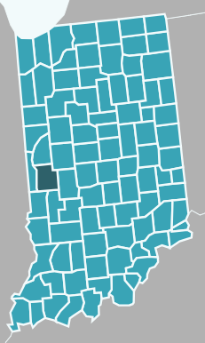
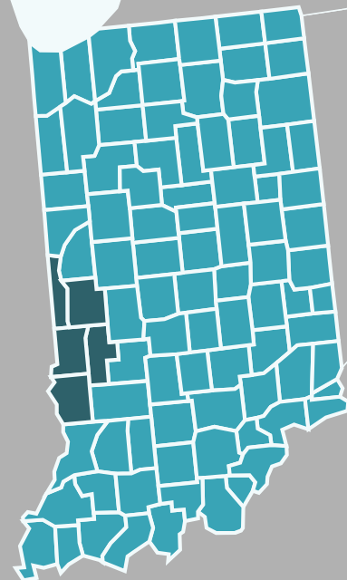
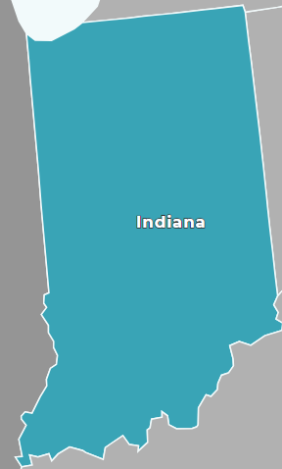
State of Indiana Terre Haute MSA Parke County

Measures of Economic Impact
- Jobs Created: The number of Full-Time Equivalent (FTE) jobs created or supported by Indiana State University annually. For our purposes, these positions include paid employees, sole proprietors, and owners or operators and are sustainable over an entire calendar year.
- Labor Income: The wages (or earnings) plus the value of the benefits paid to the employees whose jobs are created directly by Indiana State University or supported by its operations.
- Gross Domestic Product: Reported as “Value Added” in the IMPLAN software, this is the annual measure of the labor income added to the value of the goods and services produced annually either by ISU operations or the collection of industries supported by its presence in the region.
- Tax Revenue: Disaggregated across multiple levels of government (sub-county, county, state, and federal), the tax revenue is the annual value of income, sales, property, permit, and special district levies that are collected due to the operations of Indiana State University.
To add precision to our analysis, we complete “nested” economic impact modeling for Indiana State University, gauging the ripple effect of its impact across 3 geographic regions: the Terre Haute MSA, Parke County, and the state of Indiana as a whole. By isolating the unique impact at each geographic level, we can identify ISU’s ripple effect across the entire state beyond its immediate (and largest) impact on the MSA.

Modeling
TPMA utilizes IMPLAN, an economic impact analysis tool that can statistically predict direct, indirect, and induced outputs. Specifically, IMPLAN provides total output, value-added, labor income, and employment economic indicators and can provide tax results on a sub-county special district, county, state, and federal level of analysis.
IMPLAN was developed by the US Forest Service in 1978 and released for broader use in 1985. This economic modeling package remains the industry standard. It is used by economists, academics, consultants, and community planners across the United States to estimate the impact of inputs and outputs (I/O modeling).
The software can provide outputs, employment, value-added, tax, occupation, and environmental measures. Additional information on IMPLAN™, its history, as well as a discussion of data points and FAQs, can be found at: https://implan.com/history/
By way of a synopsis, driven by the most up-to-date industry level data provided by the US Bureau of Economic Analysis, the US Bureau of Labor Statistics, and proprietary modeling by its team of economists, IMPLAN™ takes known input measures for an industry or event and produces accurate estimates of the broader measures of jobs, earnings, GDP, and taxes across a region. To build the models provided below, we used input measures provided by ISU on 1.) employment, 2.) aggregate earnings of employees, 3.) repair, renovation, and upgrade expenses, 4.) future anticipated capital improvement expenses, and 5.) event attendance and revenue.
Using these known input measures, IMPLAN™ estimates the economic impact (again, measured in jobs, labor income, GDP, and taxes) of events across 3 unique levels/domains: direct, indirect, and induced. To simplify interpretation, we report the total impact (adding all 3 levels) in our summaries, but each detailed section that follows disaggregates the impacts across these levels for additional detail.

Total Output Impact
Economic Impact Modeling: Day-to-Day Operations
The first type of economic impact we calculate is driven by Indiana State University's daily operations. As part of its ongoing mission, faculty, staff, and students all complete important functions on campus and, in return, produce value in goods and services, earn wages, and contribute to taxes. Using the employment and payroll data provided by ISU for Fiscal Year 2024 (Table I) as the inputs in the IMPLAN operations model, we can isolate the direct, indirect, and induced impact the University has on the MSA, the ripple effect into neighboring Parke County, and the broader impact throughout Indiana.
Table II: Fiscal Year 2024, Aggregate Employment and Wages
 | Faculty | Staff | Students | Total
Employee Count | 628 | 1,240 | 1,848 | 3,716
Gross Earnings | $36,464,275 | $51,271,136 | $7,468,822 | $95,204,233
Social Security & Medicare - University Share | $2,648,127 | $3,618,754 | $59,763 | $6,326,644
Health Coverage | $3,883,479 | $7,412,979 | $0 | $11,296,458
Life Insurance | $45,480 | $98,788 | $0 | $144,267
Long Term Disability Insurance | $89,278 | $102,513 | $0 | $191,791
Retirement Contributions | $3,141,787 | $5,271,245 | $0 | $8,413,032
Total - Earnings & Benefits | $46,272,426 | $67,775,415 | $7,528,585 | $121,576,427

To estimate the extended direct, indirect, and induced impacts, the inputs are highlighted in the table above; specifically, 3,716 Employees receiving $121,576,427 in aggregated wages and benefits. Table II below reports the full results of 3 separate models for economic impact based on these inputs, each capturing a unique geography. The first model isolates the impact on the Terre Haute MSA, the second model isolates the “ripple” out into Parke County, and the last captures the broader, statewide impact of ISU day-to-day operations.

Table III: Full Impact Models, Day-to-Day Operations
Employment
 | Terre Haute MSA | + Parke County | +Indiana | TOTAL
Direct | 3,716.00 | - | - | 3,716.00
Indirect | 225.27 | 0.17 | 30.31 | 255.74
Induced | 493.45 | 18.45 | 150.35 | 662.25
 | 4,434.72 | 18.62 | 180.66 | 4,633.99
Labor Income
 | Terre Haute MSA | + Parke County | +Indiana | TOTAL
Direct | $126,240,976 | - | - | $126,240,976
Indirect | $10,134,610 | $7,648.08 | $1,355,833.14 | $11,498,091
Induced | $23,668,800 | $433,862.87 | $14,150,133.11 | $38,252,796
 | $160,044,386 | $441,510.95 | $15,505,966.24 | $175,991,863
Value Add (GDP)
 | Terre Haute MSA | + Parke County | +Indiana | TOTAL
Direct | $156,855,385 | - | - | $156,855,385
Indirect | $20,096,509 | $14,865.79 | $2,688,860.61 | $22,800,235
Induced | $44,678,836 | $1,195,380.61 | $22,773,588.36 | $68,647,805
 | $221,630,730 | $1,210,246.40 | $25,462,448.97 | $248,303,425

As should be expected, the bulk of the economic impact of ISU’s day-to-day operations is felt in the Terre Haute MSA. Based on the modeling, the 3,716 Direct employees of the university, through their day-to-day efforts and including the paychecks and benefits they earn, account for $156.9 million in Value Added to the MSA’s economy. “Value Added”, a measure of an industry or entity’s contribution to the overall GDP of a region and includes the $126.2 million in Labor Income (employee earnings and benefits), as well as $30.6 million in proceeds from services, events, conferences, space rental, etc. and the affiliated taxes on production and imports (TOPI). To simplify interpretation, we also isolate the goods, services, and TOPI number by subtracting the Labor Income from the total Value Added, labeled “Value Added, Less Labor Income” in the table above.
The day-to-day activities of the University and its employees also create an additional 225.27 FTE (Full-Time Equivalent) Indirect jobs in the MSA. These jobs exist to create the goods and services purchased by the University to conduct its regular, day-to-day operations (e.g. the other industries in ISU’s “supply chain”) items such as office supplies, catering services, consulting services, technology and equipment purchases, etc. The 225 “supply chain” employees collectively earn $10.1 million annually in Labor Income, through their efforts, produce $9.96 Million in goods, services, and tax revenue for a total annual contribution to MSA GDP (Value Added) of nearly $20.1 Million.
Finally, in terms of Induced impact, employees of ISU (3,716) of ISU and its regional suppliers (225.27 FTE) spend a portion of their paychecks within the region itself, creating additional jobs, earnings, and Value Added to GDP for the MSA. Specifically, their spending within the community creates an additional 493.45 FTE jobs, paying $23.7 million in wages and benefits (Labor Income). The goods and services produced by these workers and their affiliated TOPI account for an additional $21 million in profits for their collective industries. The labor income and industry profits add approximately $44.7 million in value to the MSA’s annual GDP.
In addition to the impact on the Terre Haute MSA, the table above also isolates the additional effects in Parke County and across Indiana. Summing across all 3 levels shows that, in total, the day-to-day operations of ISU support 4,634 jobs, generating $176 million in labor income, adding $248 million to Indiana’s GDP.

Figure VI: Total Annual Economic Impact Day-to-Day Operations of ISU

*Includes the Terre Haute MSA, Parke County, and the state of Indiana

While the figure above sums the economic impact across the MSA, Parke County, and the state, the figure on the next page highlights the nested nature of the impact: isolating the jobs, earnings, GDP, and taxes generated at each geographic level. Full breakouts of the taxes generated- at the direct, indirect, and induced levels follow in Table III.

Figure VII: The Nested Regional Impact of Indiana State University (Day-to-Day Operations)

Tax Impact
In addition to the TOPI tax embedded in the added modeling above, this economic activity generates tax revenue across all levels of government. The Table below breaks out the specific contributions of ISU (direct), its suppliers (Indirect), and the dollars spent by their employees (induced) by the level of government.

Table IV: Annual Tax Revenue Generated By Tax and Impact Level
Impact Level | Sub County General | Sub County Special Districts | County | State | Federal | Total, Impact Level
Direct | $309,784 | $594,620 | $1,060,029 | $5,914,473 | $26,943,587 | $34,822,494
Indirect | $69,692 | $134,878 | $154,663 | $955,387 | $2,390,095 | $3,704,716
Induced | $318,399 | $617,884 | $577,577 | $3,512,759 | $5,622,969 | $10,649,588
Total, Government | $697,875 | $1,347,382 | $1,792,270 | $10,382,619 | $34,956,652 | $49,176,797

While tax impact was calculated using the same nesting model approach (isolating the MSA, adding Parke County, and then adding the rest of the state), the above results represent the totals across all levels. Consistent with the patterns of earnings and GDP presented earlier, most of the county and sub-county tax revenue is generated in the Terre Haute MSA.
Economic Impact: Maintenance, Repairs, Renovations, and Upgrades
In addition to the routine maintenance and repairs completed by Indiana State University employees, outside contractors are often brought in to assist with specific maintenance, repair, and upgrade projects on an as-needed basis. Over the last 12 months, ISU has spent $4.071 million on these projects, detailed below in Table IV.

Table V: Fiscal Year 2023/24 Repairs, Renovations, and Upgrades
Type of Activity: Repairs and Renovations
Project Name | Project Start | Project End | Cost of Project
Air Quality | 1-Jul-23 | 30-Jun-24 | $40,000.00
Satellite Chilled Water Plant Repairs | 1-Jul-23 | 30-Jun-24 | $335,642.00
Elevator Repairs | 1-Jul-23 | 30-Jun-24 | $62,300.00
Fine Arts Steam Line | 1-Jul-23 | 30-Jun-24 | $104,160.12
Repair of Pedestrian Way Clock | 1-Jul-23 | 30-Jun-24 | $8,425.00
FacMgt Fueling System Repair | 1-Jul-23 | 30-Jun-24 | $8,224.00
Sidewalk Repairs | 1-Jul-23 | 30-Jun-24 | $20,333.87
External Camera System Repairs/Upgrades | 1-Jul-23 | 30-Jun-24 | $183,972.24
Water Damage | 1-Jul-23 | 30-Jun-24 | $74,369.65
University Apartments Unit 1 Electrical | 1-Jul-23 | 30-Jun-24 | $149,353.00
Electric Voltage System Repairs | 1-Jul-23 | 30-Jun-24 | $600,000.00
Various Mechanical/HVAC Repairs/Replacement | 1-Jul-23 | 30-Jun-24 | $232,790.00
Native American Storage | 1-Jul-23 | 30-Jun-24 | $108,249.34
Science Chemical Storeroom | 1-Jul-23 | 30-Jun-24 | $37,234.25
Dreiser Renovation | 1-Jul-23 | 30-Jun-24 | $68,901.66
SUBTOTAL |  |  | $2,033,955.13
Type of Activity: Replacements and Upgrades
Chestnut Building Roof | 1-Jul-23 | 30-Jun-24 | $400,000.00
Condit House Stove and Hood | 1-Jul-23 | 30-Jun-24 | $19,087.05
Public Safety Main UPS Revitalization | 1-Jul-23 | 30-Jun-24 | $23,960.00
Lighting Replacements/Upgrades | 1-Jul-23 | 30-Jun-24 | $194,051.71
High Voltage Replacement | 1-Jul-23 | 30-Jun-24 | $15,068.91
Landini Center for Performing and Fine Arts Reroof | 1-Jul-23 | 30-Jun-24 | $1,000,000.00
Fine Arts Masonry Repair | 1-Jul-23 | 30-Jun-24 | $133,217.00
Parking Lot Repairs | 1-Jul-23 | 30-Jun-24 | $67,180.00
SUBTOTAL |  |  | $1,852,564.67
Type of Activity: Miscellaneous
7th & Cherry Gateway | 1-Jul-23 | 30-Jun-24 | $11,040.00
Brazil Field Campus demolition of Climbing Wall & Building | 1-Jul-23 | 30-Jun-24 | $33,938.26
8th Street Animal Facility | 1-Jul-23 | 30-Jun-24 | $113,121.33
Honors College Furniture Replacement (Pickerel) | 1-Jul-23 | 30-Jun-24 | $26,398.84
SUBTOTAL |  |  | $184,498.43
TOTAL, ALL TYPES |  |  | $4,071,018.23

These investments create/sustain employment opportunities and labor income, GDP, and additional tax revenue in the same manner as ISU’s day-to-day operations, albeit on a smaller scale. To calculate these economic impacts (jobs, earnings, GDP, and taxes), we enter the value of the services procured by the project and target industry into IMPLAN™ as the primary input. In this event analysis, we know the final value of the goods but not the number of jobs or earnings of the workforce engaged in their delivery. However, by entering the final value of the goods/services by specific industry sectors, the resulting wages, jobs, and GDP estimates are highly accurate and precise. Table IV above includes the IMPLAN™ industry sector designations and the aggregated annual economic impact of these projects for Fiscal Year 2023/2024 appears in Table V below.
Table VI: Maintenance, Repairs, and Upgrades Economic Impact by Level and Region
Employment
 | Terre Haute MSA | + Parke County | +Indiana | TOTAL
Direct | 16.08 | - | - | 16.08
Indirect | 6.35 | 0.05 | 1.46 | 7.86
Induced | 4.61 | 0.40 | 1.94 | 6.95
 | 27.04 | 0.45 | 3.40 | 30.89
Labor Income
 | Terre Haute MSA | + Parke County | +Indiana | TOTAL
Direct | $927,567 | - | - | $927,567
Indirect | $333,639 | $1,999.38 | $183,238.81 | $518,877
Induced | $220,994 | $14,897.57 | $165,534.06 | $401,426
 | $1,482,200 | $16,896.94 | $348,772.87 | $1,847,870
Value Add
 | Terre Haute MSA | + Parke County | +Indiana | TOTAL
Direct | $4,071,018 | - | - | $4,071,018
Indirect | $1,302,061 | $3,851.73 | $598,589.82 | $1,904,503
Induced | $730,303 | $61,090.68 | $445,395.90 | $1,236,790
 | $6,103,382 | $64,942.41 | $1,043,985.72 | $7,212,310

Again, as we would expect, the bulk of the economic impact for repairs, maintenance, and upgrades undertaken by ISU in FY23/24 fell within the Terre Haute MSA, with the investments supporting 27.04 FTE jobs, with labor earnings of $1.48 Million and a trickle down net positive gain in GDP for the region of $6,103,382. Looking across all geographies (MSA, plus Parke County, plus the State of Indiana), the total economic impact of the repairs, upgrades, and maintenance in Fiscal Year 23/24 was 30.89 FTE jobs, with Labor Income of just under $1.85 million and total value added to the state’s GDP of $7.21 million. This information is presented in the figure below.

Figure VIII: FY 2023/24 Economic Impact of Repairs, Maintenance, and Upgrades to Campus Facilities
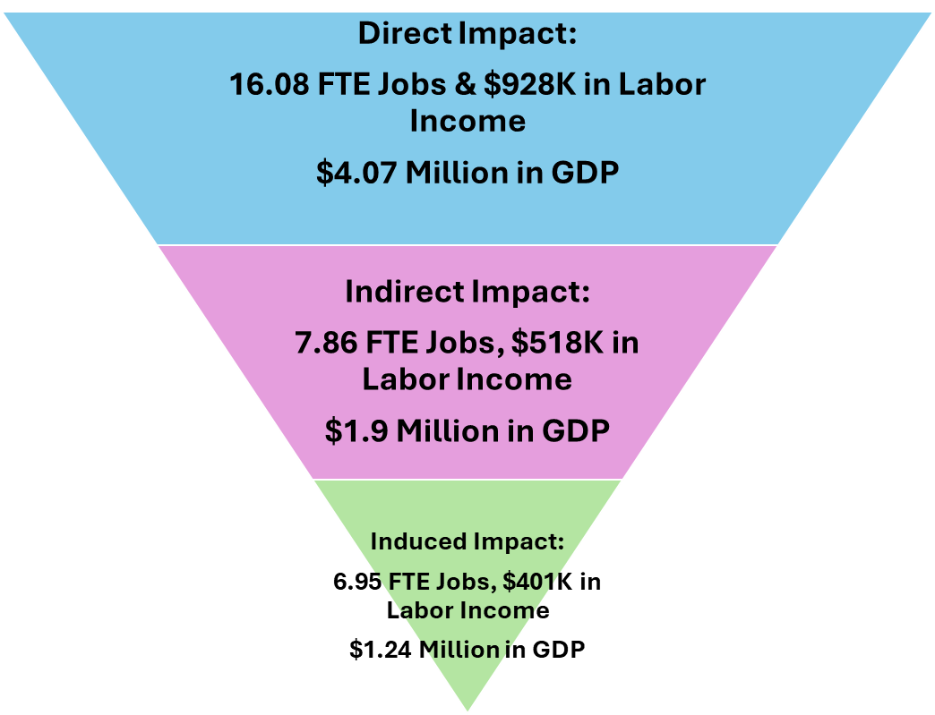
Renovations, Maintenance, and Upgrades Total Economic Impact:
30.89 FTE Jobs, $1.87 Million in Labor Income, $7.21 Million in GDP

Economic Impact: Planned Capital Improvements
In addition to the regular investments in maintenance, repairs, and upgrades to existing facilities on campus, Indiana State University is also investing/planning to invest in 2 major capital expansion projects. The first, an Early Childhood Development Center, is slated to be completed in 2025. The second, the Center for Technology, Engineering, and Design, will see construction completed by the end of 2026. Like the process followed above to estimate the impact of maintenance, repairs, and upgrades, we can take the cost of these projects as inputs and model the jobs, wages, GDP, and tax revenue that can be attributed to their construction.
There are a few tweaks to the modeling that are worth noting here. First, as we are spreading these projects across multiple years, the economic impact of employment is best understood as job years, not jobs in the traditional sense. IMPLAN™ models events one year at a time, so to accurately gauge multi-year initiatives, the investments (inputs in the model) need to be divided across multiple years. The results are one model for 2025 and one for 2026, each based on a partial investment (half of the allotted budget for the Tech Center). One implication is that the jobs reported per year may or may not be held by the same individuals working for multiple years on the same initiatives, so it is incorrect to simply aggregate the jobs across both years and report the resultant figure as the number of jobs created. To sidestep this aggregation and isolation of unique job challenges, we report this impact component as “job years” associated with the projects.
Second, there is the challenge of predicting and controlling future cost increases driven by systemic inflation or idiosyncratic changes in the region, impacting the cost of labor, materials, and services. IMPLAN™ does slightly adjust future years' output upwards based on past inflationary trends, so the total output of these projects- as reported by IMPLAN- comes in at $76.6 million, slightly higher than the total investment reported by ISU ($75.8 million). Other than this modest adjustment to future costs, we assume relative stability in inflationary pressure through 2026 and report the economic impact in 2024 dollars. Still, the final value of ISU’s contribution vis-à-vis capital improvement projects could ultimately exceed the estimated increase modeled via IMPLAN™. Table VI below reports the estimated investments, by year, in these capital projects, as provided by ISU.

Table VII: Capital Projects and Estimated Annual Expenses
Project | FY 24/25 | FY 25/26 | FY 26/27 | Total Investment
Early Childhood Development Center | $9,800,000 | N/A | N/A | $9,800,000
Center for Technology, Engineering, and Design | $26,400,000 | $26,400,000 | $13,200,000 | $66,000,000
Annual Total | $36,200,000 | $26,400,000 | $13,200,000 | $75,800,000

Using these annual cost estimates- highlighted in yellow in the table above- as our input allows the construction of 3 impact models, reported in Tables VII through IX below. All told, over the next 3 fiscal years, these 2 capital projects will generate job years in labor wages and contribute in value to the state’s overall Gross Domestic Product. The table below provides a high-level summary of these projects' economic impact by year.
Table VIII: Fiscal Year 2024/25 Capital Improvements Economic Impact
 | Terre Haute MSA | + Parke County | +Indiana | TOTAL
Direct | 311.68 | - | - | 311.68
Indirect | 26.80 | 0.17 | 10.17 | 37.14
Induced | 70.03 | 5.10 | 21.75 | 96.88
TOTAL | 408.50 | 5.27 | 31.92 | 445.70
Labor Income
 | Terre Haute MSA | + Parke County | +Indiana | TOTAL
Direct | $17,806,322 | - | - | $17,806,322
Indirect | $1,618,167 | $10,509.35 | $1,136,877.50 | $2,765,554
Induced | $3,357,578 | $177,183.81 | $2,057,045.12 | $5,591,807
TOTAL | $22,782,067 | $187,693.16 | $3,193,922.61 | $26,163,683
GDP Value Add
 | Terre Haute MSA | + Parke County | +Indiana | TOTAL
Direct | $21,832,053 | - | - | $21,832,053
Indirect | $3,062,201 | $23,288.59 | $1,688,277.33 | $4,773,767
Induced | $6,341,133 | $392,636.91 | $3,304,277.33 | $10,038,048
TOTAL | $31,235,388 | $415,925.49 | $4,992,554.66 | $36,643,868

In the first year of construction, based on an estimated cost to ISU of $36.2 million, construction of the Early Childhood and Technology, Engineering, and Design will support 445.7 FTE jobs, with a labor income of $26.2 million and a total contribution to GDP of just over $36.3 million. These numbers include the Terre Haute MSA, Parke County, and the state of Indiana. The most significant bumps from Parke County and all of Indiana occur in the Induced impact category, as construction workers and their suppliers spend their earnings throughout the state, creating additional jobs, earnings, and GDP.
Table IX: Fiscal Year 2025/26 Capital Improvements Economic Impact
 | Terre Haute MSA | + Parke County | +Indiana | TOTAL
Direct | 227.30 | - | - | 227.30
Indirect | 19.54 | 0.12 | 7.42 | 27.09
Induced | 51.07 | 3.72 | 15.86 | 70.65
TOTAL | 297.91 | 3.84 | 23.28 | 325.04
Labor Income
 | Terre Haute MSA | + Parke County | +Indiana | TOTAL
Direct | $12,985,640 | - | - | $12,985,640
Indirect | $1,180,083 | $7,664.17 | $829,092.19 | $2,016,839
Induced | $2,448,586 | $129,215.07 | $1,500,144.08 | $4,077,945
TOTAL | $16,614,309 | $136,879.25 | $2,329,236.28 | $19,080,424
GDP Value Add
 | Terre Haute MSA | + Parke County | +Indiana | TOTAL
Direct | $14,075,404 | - | - | $14,075,404
Indirect | $2,016,839 | $16,983.70 | $1,231,212.30 | $3,265,035
Induced | $4,077,945 | $286,338.85 | $2,409,714.81 | $6,773,998
TOTAL | $20,170,187 | $303,322.55 | $3,640,927.11 | $24,114,437

With projected construction costs for FY 2025/26 decreasing from $36.2 to $26.4 million, the overall economic impact also decreases proportionally to the investment. In the second year of these capital projects, ISU’s expenditures will support 325 FTE jobs, with a collective labor income of just over $19 million and a total contribution to the state’s GDP of $24.1 million. Once again, these numbers include the MSA, Parke County, and the state of Indiana as a whole

Table X: Fiscal Year 2026/27 Capital Improvements Economic Impact
 | Terre Haute MSA | + Parke County | +Indiana | TOTAL
Direct | 113.62 | - | - | 113.62
Indirect | 9.77 | 0.06 | 3.71 | 13.54
Induced | 25.53 | 1.86 | 7.93 | 35.32
 | 148.91 | 1.92 | 11.64 | 162.47
Labor Income
 | Terre Haute MSA | + Parke County | +Indiana | TOTAL
Direct | $6,490,956 | - | - | $6,490,956
Indirect | $589,872 | $3,830.99 | $414,427.08 | $1,008,130
Induced | $1,223,941 | $64,588.99 | $749,856.69 | $2,038,387
 | $8,304,769 | $68,419.97 | $1,164,283.77 | $9,537,473
GDP Value Add
 | Terre Haute MSA | + Parke County | +Indiana | TOTAL
Direct | $7,958,460 | - | - | $7,958,460
Indirect | $1,116,267 | $8,489.41 | $615,429.40 | $1,740,186
Induced | $2,311,540 | $143,128.32 | $1,204,511.48 | $3,659,179
 | $11,386,267 | $151,617.73 | $1,819,940.88 | $13,357,825

Based on estimates from ISU that peg completion of the Center by January of 2027, we estimate the final year of construction investment will come in at $13.2 million, which results in an additional decrease in the number of jobs, earnings, and GDP generated. Based on this projected investment, in FY2026/27, ISU’s investments in Capital Projects will support 162.47 FTE jobs, with labor income of $9.54 million and value added to the state’s GDP totaling just under $13.4 million.
Throughout the projects, from FY 2024/25 through FY 2026/27, construction investments from ISU will generate 933.2 Job Years, with a Labor Income of $54.8 Million and generate a total GDP of $74.1 Million. The figure below provides high-level summaries, year by year, across all levels of impact (direct, indirect, and induced).

Figure IX: Annual Impact, Capital Projects, All Levels, FY 2024/25 through FY 2026/27
TOTAL IMPACT, CAPITAL IMPROVEMENT PROJECTS
933.2 Job Years ~ $54.8 Million in Labor Income ~ $74.1 Million in Additional GDP

Economic Impact: Sporting and Special Events
As the final, fourth leg of our economic impact analysis of Indiana State University, we model the broader economic impact on the Terre Haute MSA region, driven by the events hosted on the ISU campus. In terms of methodology, there are some tweaks to this modeling, most notably excluding any Direct impact in the final report out of total dollars/jobs/and GDP. Because the direct impact is driven solely by the wages and GDP generated by employees of the University who staff events, and this value was already calculated as part of the day-to-day operations of the University, including it as a separate line in this events impact analysis would essentially double count their wages and GDP. Similarly, the supply chain employees and their earnings, those who provide the goods and services to ISU to ensure that events can be hosted on campus, are also included in the Day-to-Day operations section. They are also excluded from the events analysis totals. Both levels appear in the modeling table below but are excluded as additional jobs/revenue as part of the final estimation of additional economic impact.
What is left is the induced impact felt in the greater Terre Haute MSA. This induced impact is made up of the money visitors spend on accommodations, restaurants, fuel, supplies, materials, and services while in the region attending one or more events identified by ISU. These events, including attendance and gross receipts, are reported by ISU (reproduced in Table X below) and are inputs in the IMPLAN™ event modeling.
Table XI: Attendance and Gross Receipts by Venue, Fiscal Year 2023/24
Venue | Events | Attendance | Gross Receipts
Hulman Center | 53 | 165,879 | $2,149,609
Tilson Auditorium | 17 | 16,144 | $38,086
Student Union | 11 | 2,935 | $9,334
Bob Wam Field | 18 | 22,149 | $58,680
Memorial Stadium | 6 | 18,382 | $65,768
Gibson Track and Field | 3 | 1,541 | $14,170
TOTAL | 108 | 227,030 | $2,335,646

Between July 2023 and June 2024, ISU events attracted 227,030 spectators to the greater Terre Haute MSA, generating $2,335,646 in gross receipts for the University. Using these counts as our inputs for economic modeling, the resultant impact analysis appears below in Table XI, followed by the tax revenue impacts in Table XII.
Table XII: FY 2023/2024 Events Impact Analysis- Terre Haute MSA
 | Employment | Labor Income | GDP/Value Added
Direct | 52.00 | $719,378.62 | $2,335,646
Indirect | 10.56 | $232,232.90 | $957,993.60
Induced | 3.80 | $181,626.76 | $600,937.71
TOTAL | 66.36 | $1,133,238.28 | $3,917,187.83

Table XIII: Tax Revenue by Government Level, from ISU Events, FY23/24
 | Sub County General | Sub County Special Districts | County | State | Federal | Total
Direct | $28,263 | $54,927 | $45,329 | $268,571 | $136,783 | $533,873
Indirect | $7,963 | $15,475 | $12,785 | $76,724 | $51,498 | $164,446
Induced | $2,449 | $4,752 | $4,440 | $27,016 | $43,205 | $81,862
TOTAL | $38,674 | $75,154 | $62,555 | $372,310 | $231,487 | $780,181

The events themselves- attended by 227,030 spectators and generating $2.3 million in gross receipts for ISU contribute, specifically, to an additional 10.56 FTE INDIRECT jobs in the region, generating an extra $958k in additional GDP/Value Added. In terms of Induced impact- that category that captures auxiliary spending by attendees who visit the region for these events supports an additional 3.8 FTE jobs in the region, generating an additional $182k in labor income and $601k in GDP added to the region’s economy. All told, the original $2.3 million in event gross receipts multiplies up to a total of $3.9 million in GDP for the region and $780,181 in additional tax revenue. The Figure below summarizes these findings by impact level.
Figure X: The Economic Impact of ISU Events, FY2023/24
TOTAL IMPACT, EVENTS FY2023/24
66.3 FTE Jobs, $1.13 Million Labor Income, $3.9 Million in GDP, $789K in Tax Revenue

Conclusion

“Mission.” Indiana State University, Accessed 10/1/2024 Mission | Indiana State University
“Enrollment Summary.” Indiana State University, Accessed 10/1/2024 ES_S24.pdf
“Career Center.” Indiana State University. Accessed October 1, 2024, Career Center | Indiana State University
“Population Demographics Report” Lightcast™. Terre Haute MSA.
“Industry Table.” Lightcast™. Terre Haute MSA.
“Industry Table.” Lightcast™. Terre Haute MSA.
For a full discussion of Value Added, its components, and its relationship to GDP and Total Output (not reported here, but in short, this is Value Added + the Cost of Intermediate Goods consumed by an industry), please visit: https://support.implan.com/hc/en-us/articles/360017144753-Understanding-Value-Added-VA
What is NOT included in these supply chain purchases are construction related services attached to capital improvement and/or renovation projects; these are covered in a later section of the report.
Additional information and schema for IMPLAN™ 546 unique industry sectors can be found at: https://support.implan.com/hc/en-us/articles/360034895094-Industry-Scheme

